**JavaScript Data Types**



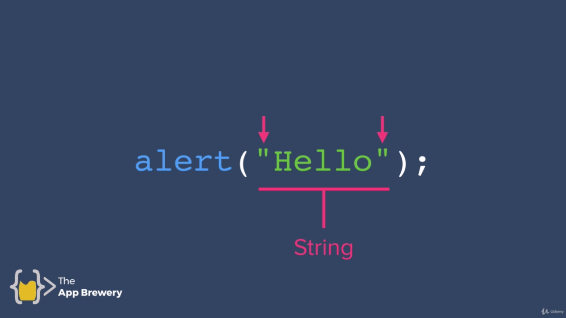

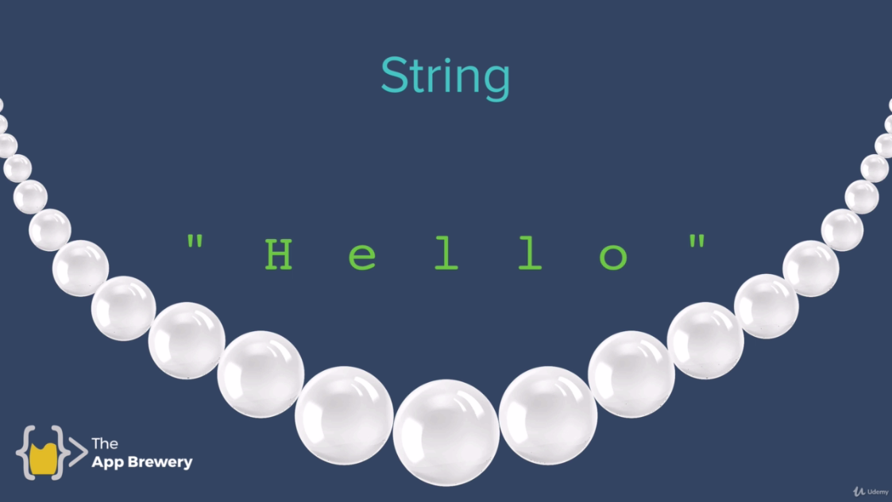

Data Types

* Number
* Boolean
* String

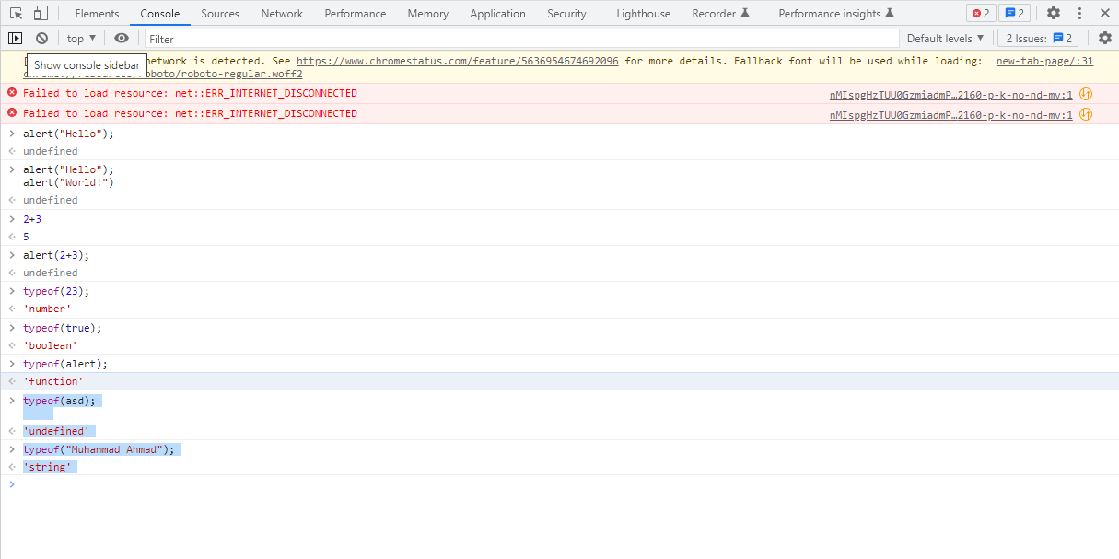

JavaScript variables can hold different data types: numbers, strings, objects and more:

let length = 16; // Number

let lastName = "Johnson"; // String

let x = {firstName:"John", lastName:"Doe"}; // Object

<https://www.w3schools.com/js/js_datatypes.asp>

When adding a number and a string, JavaScript will treat the number as a string.

Example

* let x = 16 + "Volvo";
* let x = "Volvo" + 16;

JavaScript evaluates expressions from left to right. Different sequences can produce different results:

* JavaScript:

let x = 16 + 4 + "Volvo";

Result:

20Volvo

* let x = "Volvo" + 16 + 4; Result: Volvo164 etc.

**MDN**

<https://developer.mozilla.org/en-US/docs/Web/JavaScript/Data_structures>